Comprehensive Guide: DHCP Configuration and File Sharing Permissions

# Step 1: Post-Deployment Configuration

After installing the DHCP role, Server Manager prompts for post-deployment configuration. Click 'Complete DHCP Configuration' to launch the wizard.

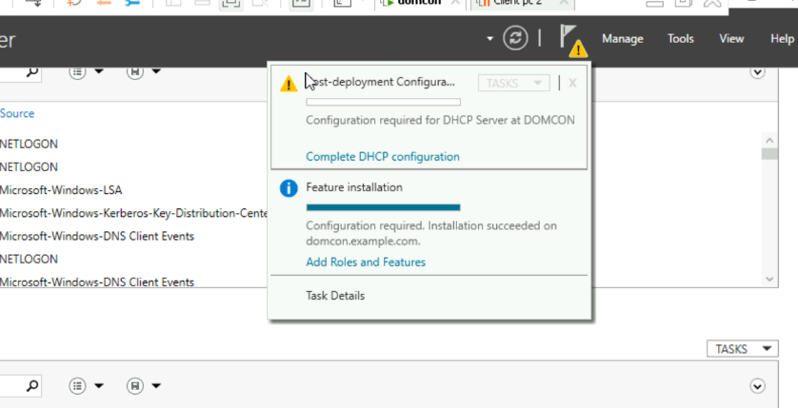

# Step 2: Feature Installation Progress

Installation of DHCP Server tools is in progress. Wait for the installation to complete successfully.

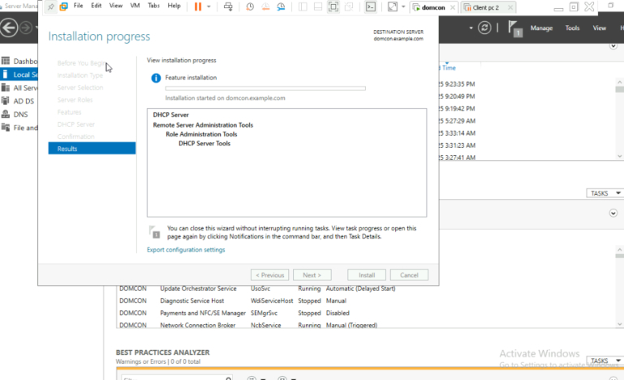

# Step 3: DHCP Post-Install Configuration Wizard

The wizard explains the creation of security groups and server authorization. Click 'Next' to proceed.

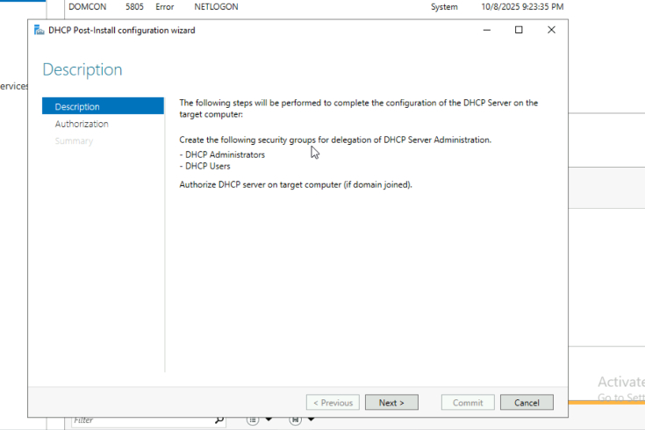

# Step 4: Authorize DHCP Server

Enter domain admin credentials to authorize the DHCP server in Active Directory and click 'Commit'.

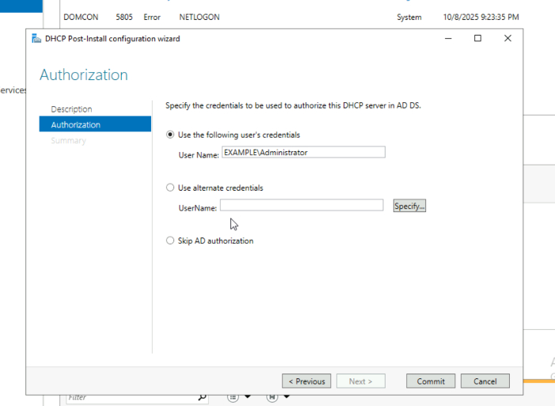

# Step 5: Configuration Summary

Confirmation that security groups are created and server is authorized. Restart the DHCP service if prompted.

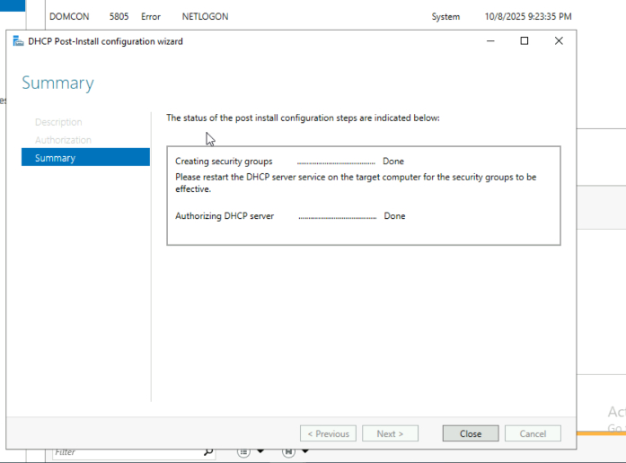

# Step 6: DHCP Scope Overview

DHCP scopes (IPv4 and IPv6) are visible under the server. Right-click IPv4 > New Scope to begin scope creation.

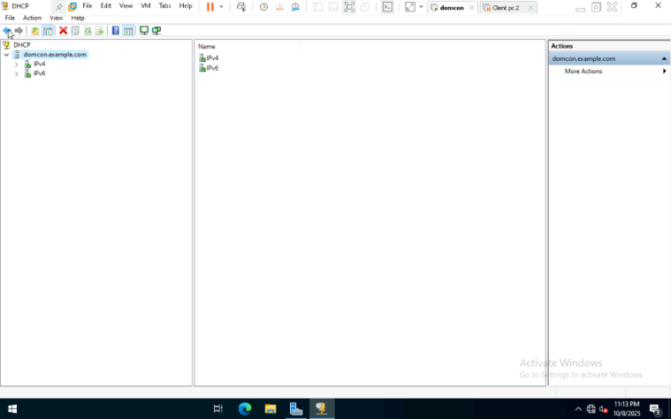

# Step 7: New Scope Wizard - Welcome

Wizard for creating a new IP address distribution scope. Click 'Next' to begin scope setup.

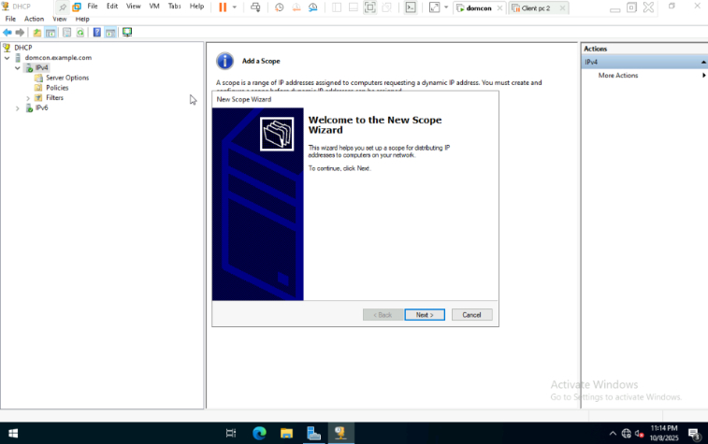

# Step 8: Define Exclusion Range

IP range 192.168.10.60 to 192.168.10.70 is excluded to prevent these IPs from being assigned dynamically.

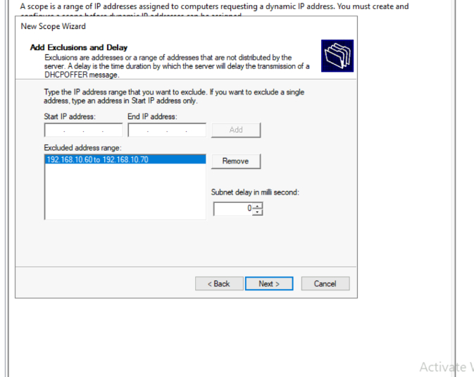

# Step 9: Add Default Gateway

Router IP 192.168.10.1 is added as the default gateway used by clients.

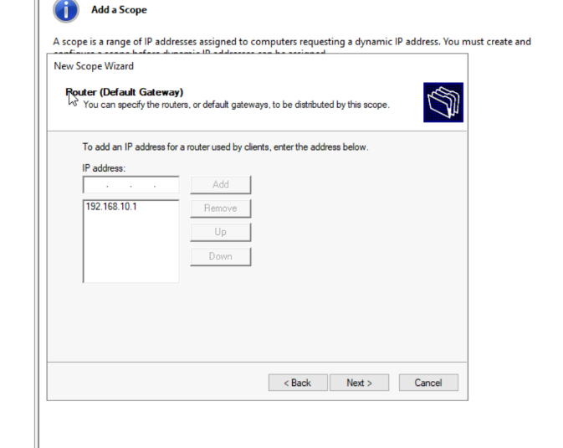

# Step 10: Lease Duration

Lease duration is set to 30 days. Choose lease duration based on network needs.

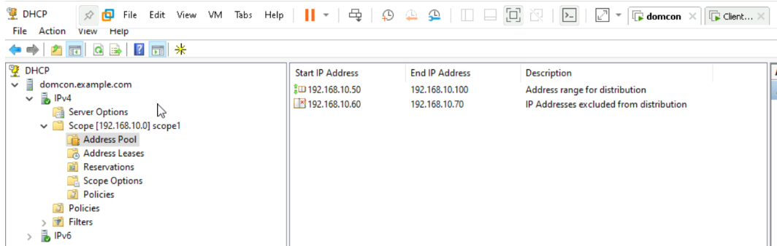

# Step 11: Scope Activation

Scope is activated immediately after creation. Select 'Yes, I want to activate this scope now'.

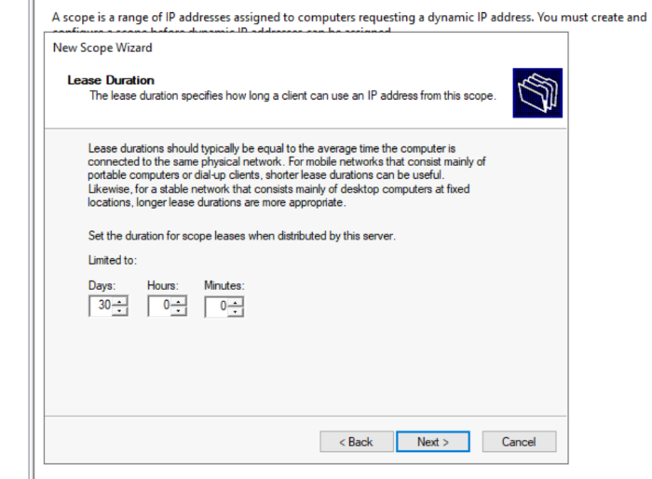

# Step 12: DNS Configuration

Enter domain name (e.g., example.com) and DNS server IPs.

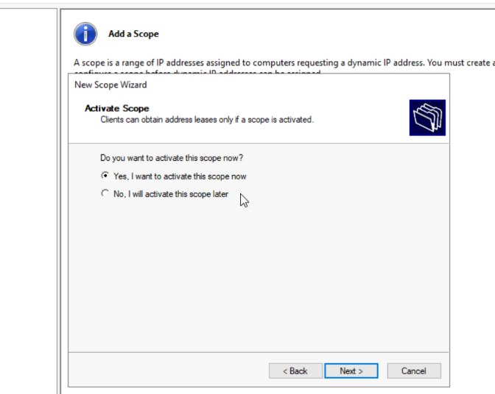

# Step 13: IP Range Setup

IP range 192.168.10.50 to 192.168.10.100 is defined for the scope.

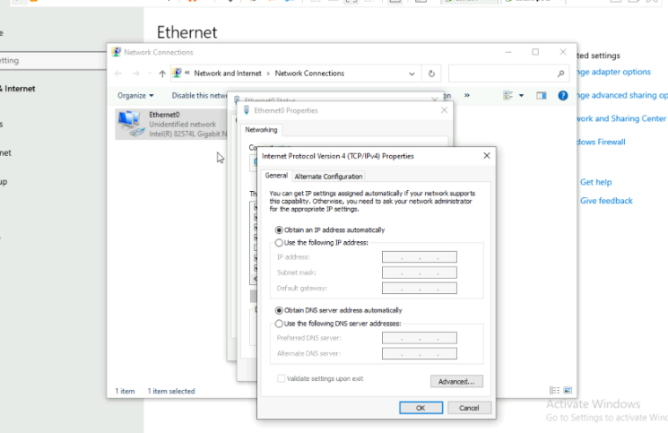

# Step 14: Client IP Assignment

Ethernet settings show automatic IP assignment. Ensure client machines are set to obtain IP automatically.

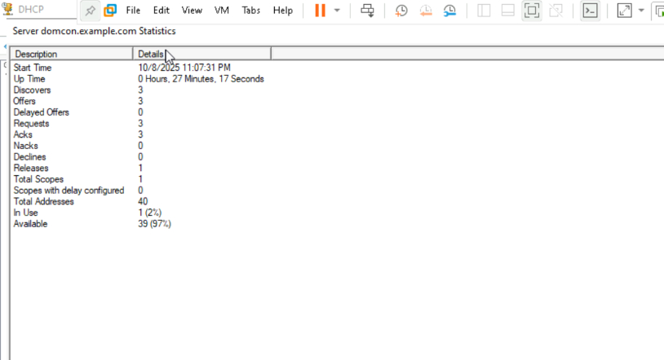

# Step 15: DHCP Server Statistics

Server statistics show uptime, offers, and usage. Monitor DHCP performance and address usage.

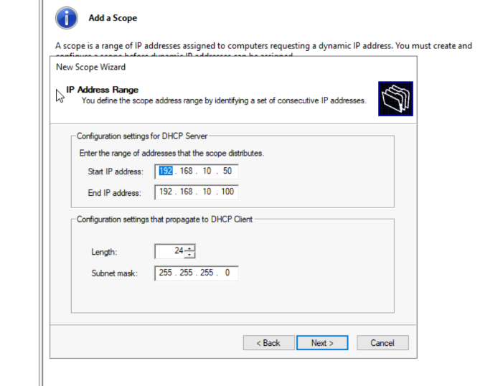

# Step 16: Lease Details

Lease information includes client details and expiration. Review active leases and manage them as needed.

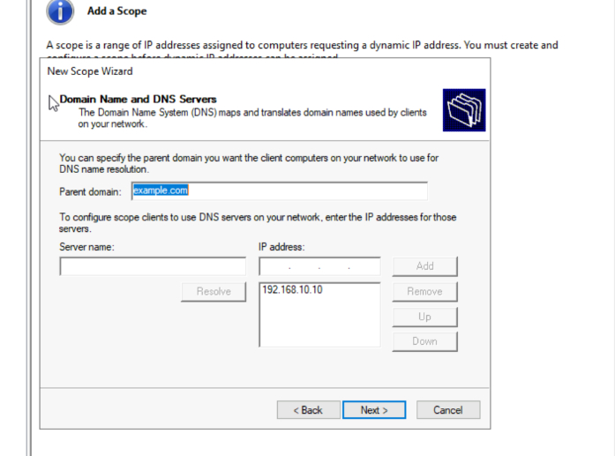

# Step 17: IP Reservation

Reservation setup for static IPs based on MAC addresses. Add reservations to ensure specific devices always get the same IP.

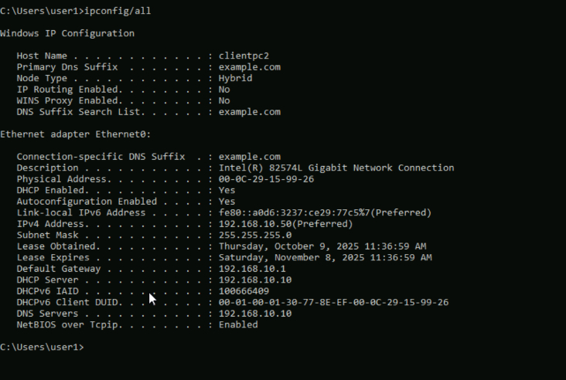

# Step 18: IP Reservation Continued

Continue adding reservations for other devices as needed.

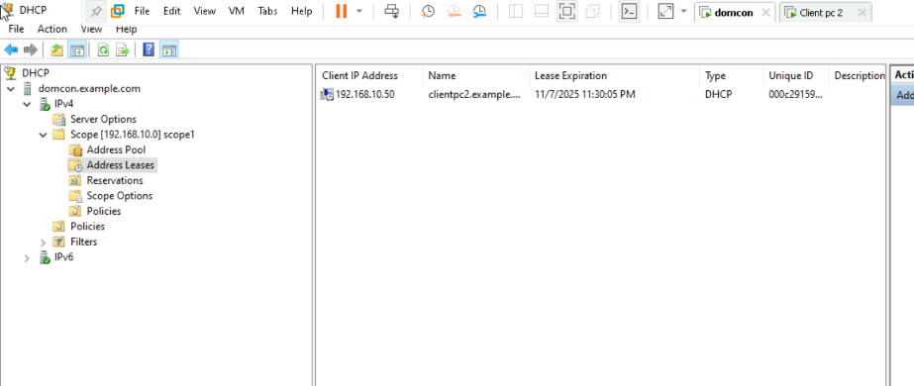

# Step 19: Final Lease Overview

Final overview of leases and reservations. Confirm all settings and monitor DHCP activity.

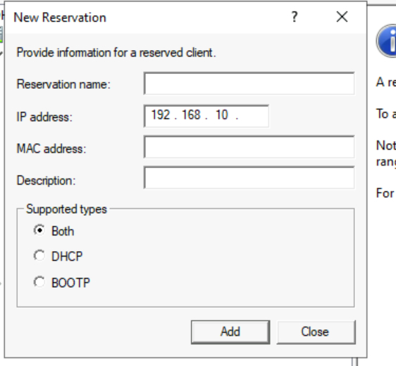

# Step 20: DHCP Lease Summary

Detailed summary of DHCP leases including client PC details like lease expiration and unique ID.

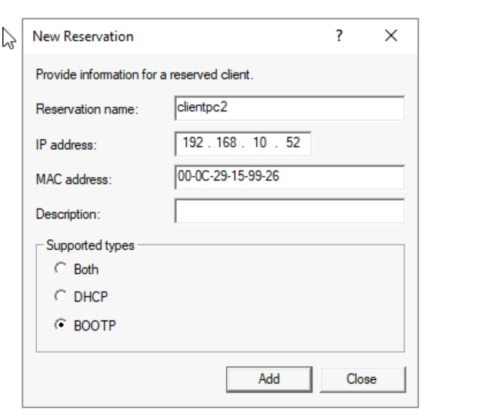

# Step 21: Block Inheritance Dialog

Advanced Security Settings for file1 showing options to convert or remove inherited permissions.

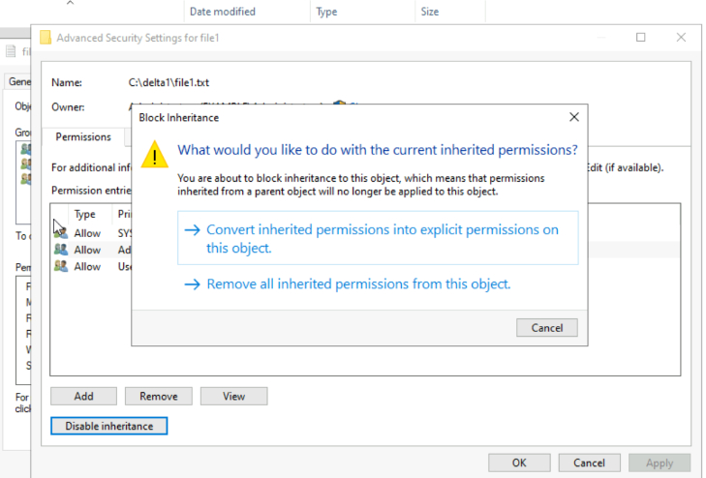

# Step 22: Permissions for file1

Lists groups and users with their respective permissions such as Full Control and Modify.

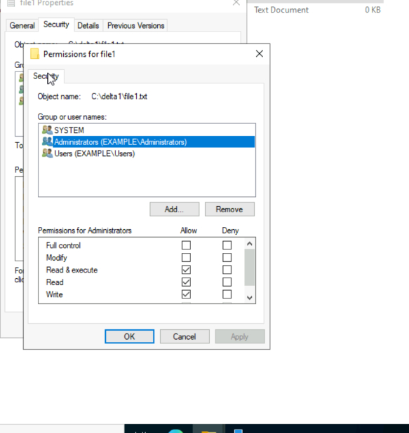

# Step 23: Active Directory User Properties

Displays user7's group memberships and administrative privileges in ADUC.

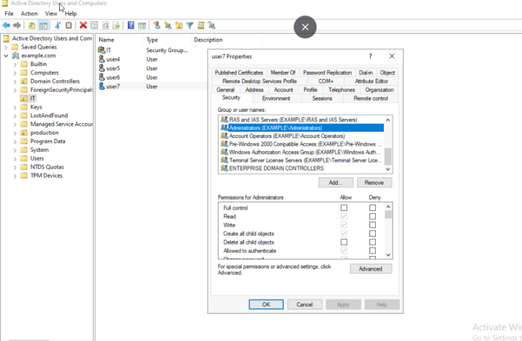

# Step 24: Folder Properties - delta1

Shows that the folder is not shared on the network with options to enable sharing.

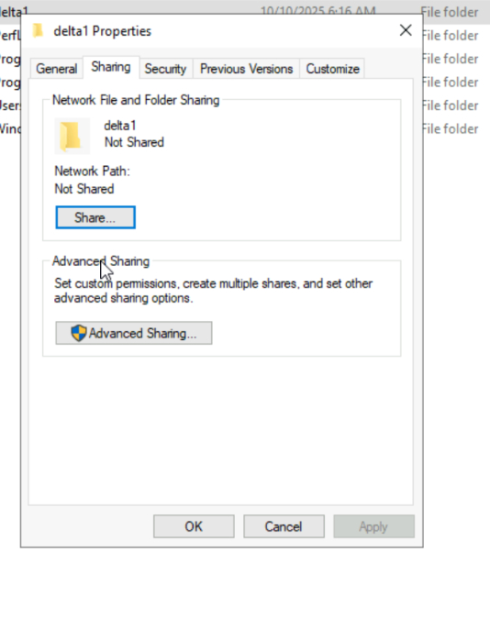

# Step 25: Folder Properties - myshareddata

Similar to delta1, confirms myshareddata is not shared.

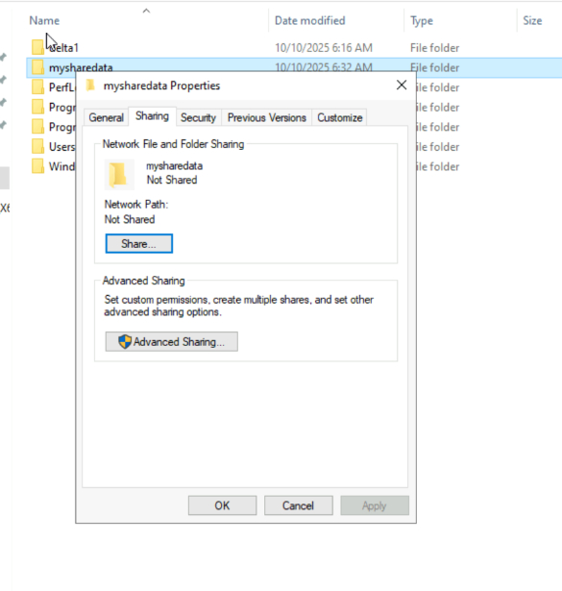

# Step 26: Advanced Sharing Settings

Advanced sharing dialog for myshareddata folder.

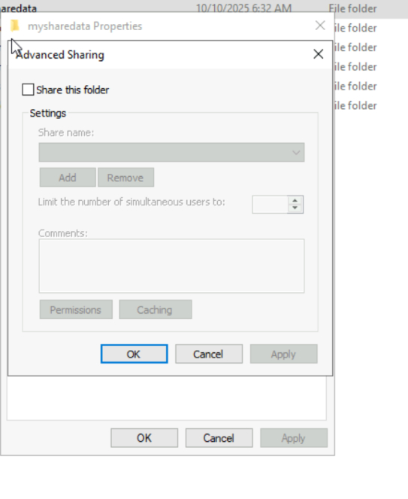

# Step 27: File Explorer - domcon

Shows shared resources under \domcon including myshareddata, NETLOGON, SYSVOL.

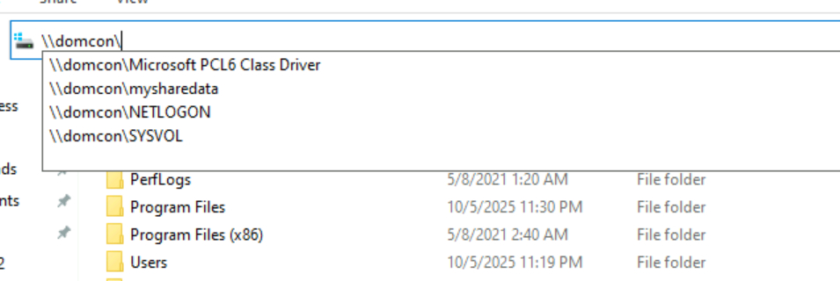

# Step 28: File Explorer - domcon

Similar view of shared resources under \domcon.

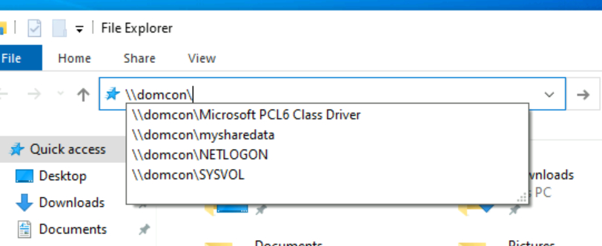

# Step 29: Access Denied Error

Notepad error indicating lack of permission to open test1.txt in myshareddata.

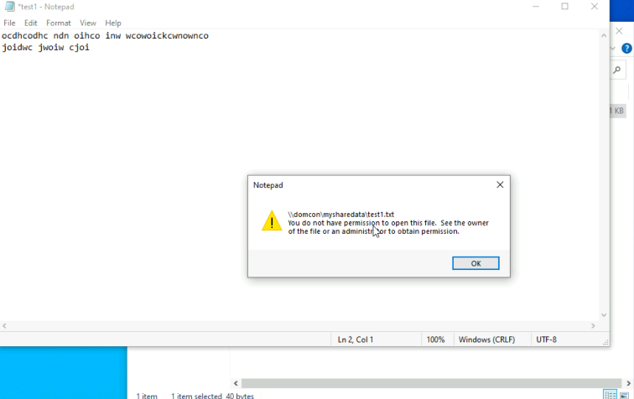

# Step 30: Add Roles and Features Wizard

Shows available server roles for installation on domcon.example.com.

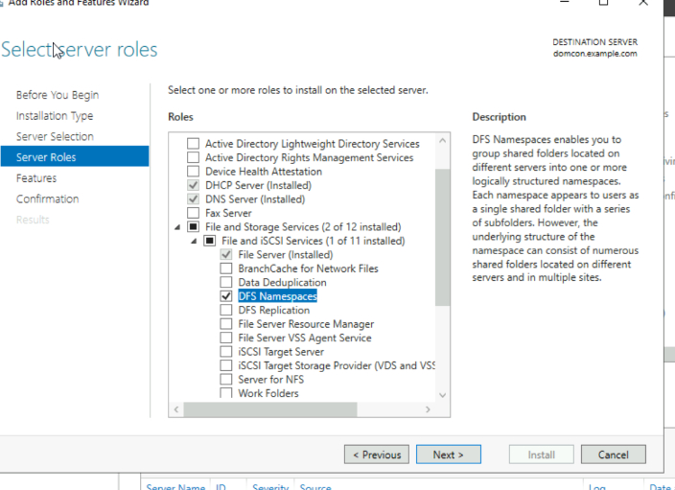

# Step 31: File Explorer - domcon

Highlights myshareddata in address bar suggestions.

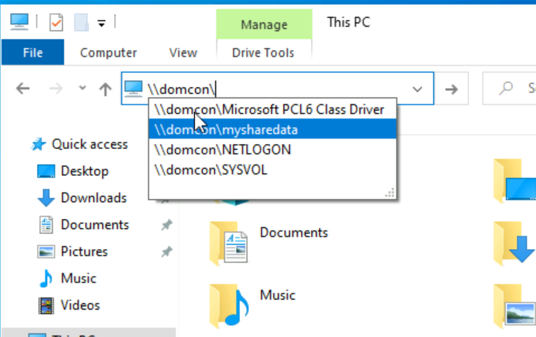

# Step 32: Installation Confirmation

Confirms installation selections including File Services Tools.

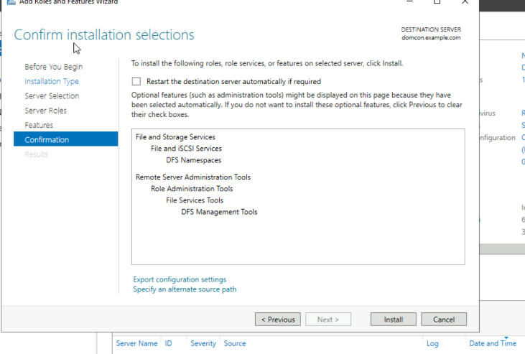

# Step 33: DFS Management Console

Namespace management screen in DFS Management.

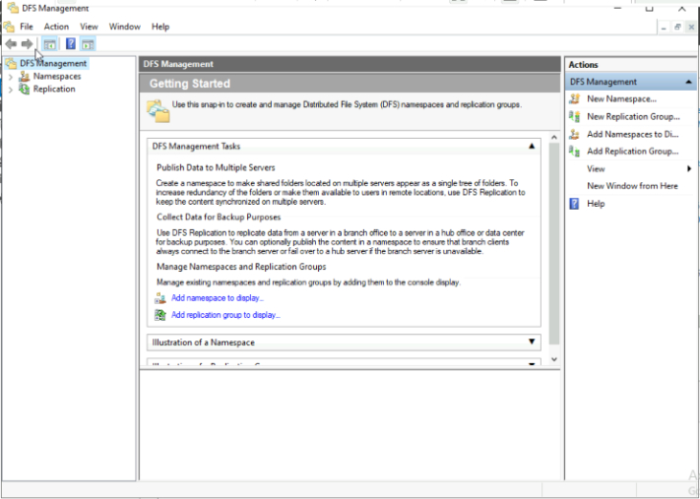

# Step 34: DFS Namespace Creation

Creating a namespace within example.com domain.

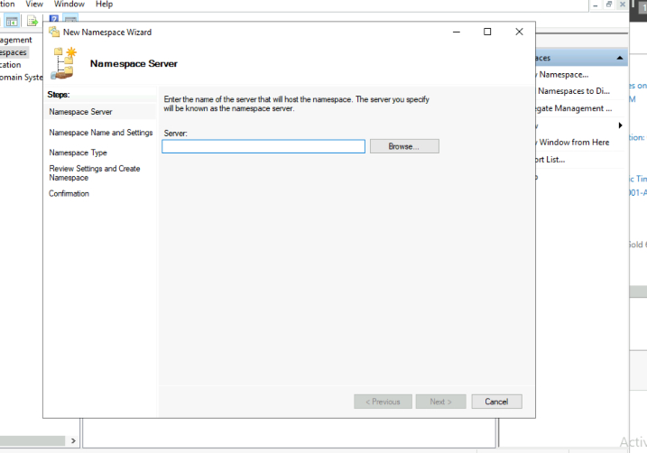

# Step 35: DFS Namespace Configuration

Configuration options for DFS namespace.

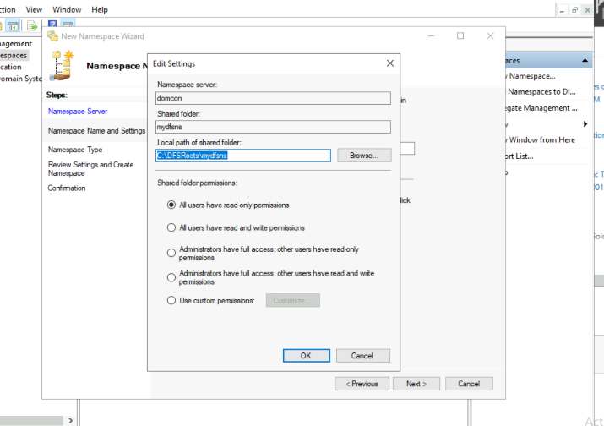

# Step 36: File Explorer - domcon

Another view of shared folders under \domcon.

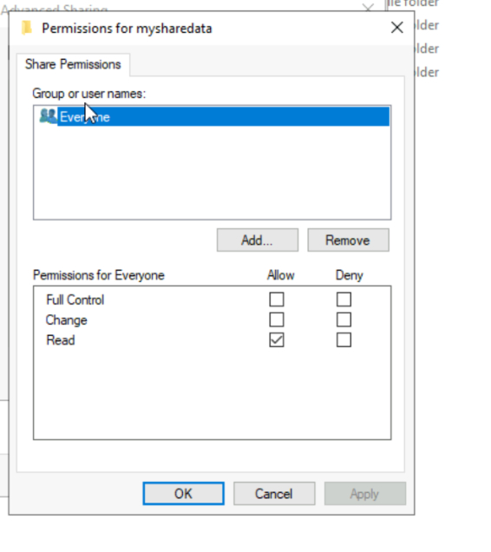

# Step 37: DFS Namespace Finalization

Finalizing DFS namespace setup.

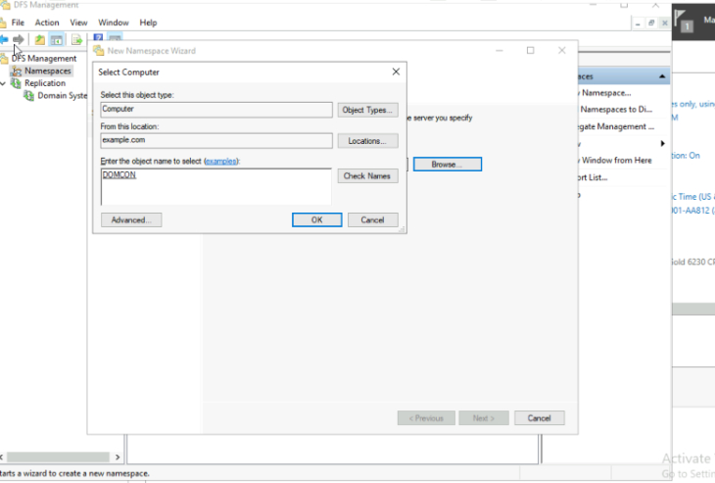

# Step 38: DFS Namespace Details

Details of created DFS namespace.

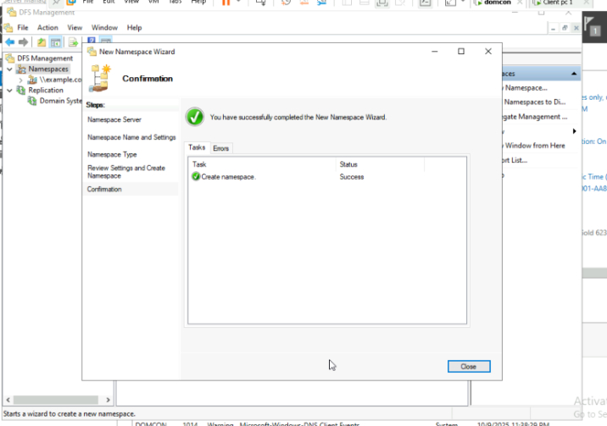

# Step 39: DFS Namespace Summary

Summary view of DFS namespace configuration.

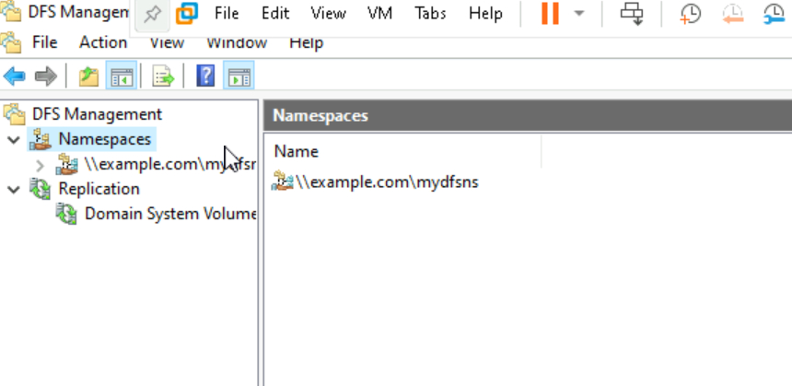

# Step 40: DFS Namespace Access

Accessing DFS namespace through File Explorer.

